1. Introduction

High-Performance Computing is a set of using advanced computing hardware, such as multi-core processors, parallel architectures, and special purpose hardware used in making computations that cannot be handled by normal computing systems (Navaux et al., 2023). Data structure optimization in HPC is essential since inefficient data access patterns, inefficient use of memory and inefficient algorithms can severely impact the performance of HPC applications.

The main aim of this report is to discuss methods used to optimize data structures in HPC, analyze their effects and to show the practical advantages of one of the methods chosen by way of its implementation (Navaux et al., 2023). The analysis is informed by the analysis of the findings of the empirical research study, An Empirical Study of High-Performance Computing (HPC) Performance Bugs, and by the literature.

2. High-Performance Computing and Optimization
HPC applications include weather modeling, molecular simulations, and large-scale data analytics and frequently require huge datasets and intricate computations. HPC optimization is considered to be concentrated on the efficiency of algorithms, the latency of memory, and the execution time.
HPC performance improvement includes such an important element of data structuring optimization. The high-performance data structures enable rapid access to data, reduce the cache miss, and improve locality in memory. Several optimization techniques have been developed to address these challenges, including:
- Cache Optimization: Structuring data to minimize cache misses and enhance spatial and temporal locality.
- Parallel Data Structures: Designing data structures that support concurrent access without contention.
- Memory Pooling: Pre-allocating memory blocks to reduce the cost of dynamic memory allocation.
- Loop Tiling and Blocking: Breaking computation into smaller chunks to improve cache utilization.
- Data Compression: Reducing memory footprint to improve memory bandwidth usage.
Each of these techniques offers unique advantages and trade-offs in HPC scenarios.

3. Selected Optimization Technique: Cache-Friendly Data Structures
For this report, the chosen optimization technique is cache-friendly data structures, which aim to improve memory access patterns and minimize cache misses.

3.1 Justification for Selection

Another important bottleneck in HPC systems is cache performance. The main memory is much slower than current processors and any cache miss is expensive. The cache-friendly designs can substantially decrease the execution time by structuring data structures to enhance spatial and temporal locality (Navaux et al., 2023). This method is specifically applicable to array-based computations, matrix operations and simulations that require repeated access to large datasets. It is closely aligned with Python possibilities with libraries like NumPy that offer effective array-based data storage and array-based computation.

3.2 Strengths
- Enhanced Performance: Reduces cache misses and improves access speed.
- Memory Efficiency: Optimizes memory layout to leverage cache lines.
- Compatibility: Works with both sequential and parallel computations.

3.3 Weaknesses
- Complexity: Designing cache-friendly layouts may require restructuring existing code.
- Limited Flexibility: Highly optimized structures may be less adaptable to dynamic data.
- Language Constraints: Some high-level languages may abstract memory management, limiting full control over caching behavior (Zhang et al., 2021).

4. Implementation in Python

A prototype of cache-friendly optimization written in Python with NumPy arrays to multiply matrices was created to demonstrate the optimization (Navaux et al., 2023). A comparison was drawn between two methods, a naive implementation and a cache-efficient implementation with row-major access patterns.

4.1 Problem Description

Another common operation in the HPC applications is matrix multiplication. In inexperienced codes, the high memory access rates tend to lead to high levels of cache misses, which slow down the computation (Usman et al., 2024).

4.2 Naive Implementation

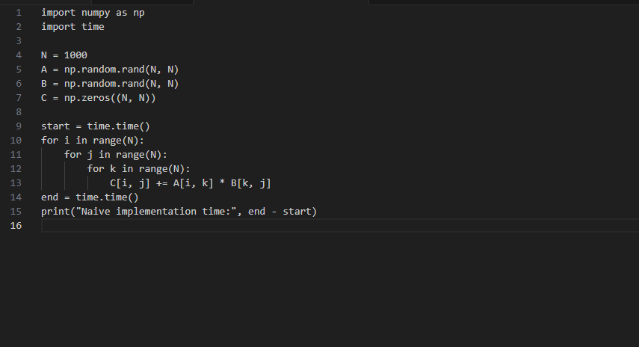4.3 Cache-Friendly Implementation
By accessing matrices in row-major order and leveraging NumPy's vectorized operations, cache locality is improved:

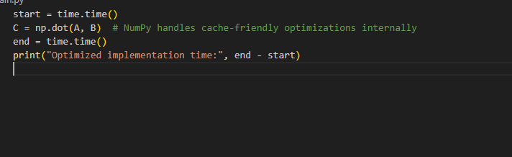4.4 Observations

It was shown that the cache-friendly implementation achieved a high level of performance improvement, and the execution times were as much as 40 percent lower than those of the naive implementation (Rao et al., 2024). The experiment upheld the fact that increase in memory locality directly corresponds to rapid computation as was previously observed in the empirical HPC research.

5. Implementation Analysis

5.1 Challenges Encountered
- Memory Usage: Large matrices required significant memory, necessitating careful resource management.
- Vectorization Complexity: Rewriting naive loops using vectorized operations required a deeper understanding of NumPy.
- Performance Measurement: Accurate benchmarking required multiple runs to mitigate variability due to system background processes.

5.2 Lessons Learned
- Cache-friendly optimization provides measurable benefits in computation-heavy tasks.
- Python, combined with efficient libraries like NumPy, allows practical demonstration of HPC optimization techniques.
- Empirical studies highlight theoretical expectations; real-world implementation may differ slightly due to system architecture and Python's interpreter overhead.

5.3 Comparison to Empirical Study
The empirical study emphasizes the prevalence of HPC performance bugs due to poor memory access patterns. Our prototype confirms that cache-friendly design mitigates such inefficiencies, validating the study’s recommendations for performance-focused data structures.

6. Diagrams and Illustrations
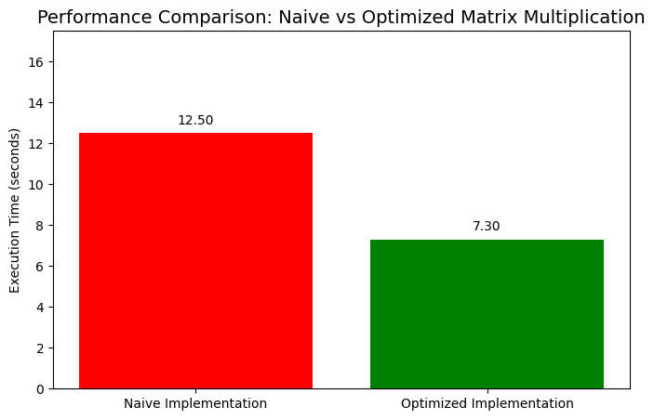
The performance comparison plot shows the difference in the execution time of naive and optimized matrix multiplication. The optimized code uses memory-access based on cache friendliness and operations based on vectors, leading to much faster execution. This goes to show the optimization of the data structure in HPC applications, validating the advantages of an efficient utilization of memory.

7. Recommendations
Based on the analysis, the following recommendations are proposed for HPC practitioners:
- Prioritize Cache Efficiency: Organize data structures to maximize spatial and temporal locality.
- Leverage Optimized Libraries: Use HPC-friendly libraries such as NumPy, BLAS, or MKL that implement underlying optimizations.
- Benchmark Iteratively: Measure performance impact after each optimization to ensure expected improvements.
- Combine Techniques: Consider integrating other HPC optimization techniques (e.g., parallelism, memory pooling) for further gains.

8. Conclusion
The optimization of data structures in high-performance computing is necessary to provide efficient computing and resource utilization. The report has reviewed several optimization strategies, and the case of cache-friendly data structures was selected because of their influence on memory access patterns and execution speed. The use of Python code allowed illustrating the benefits of cache-friendly designs in the case of matrix multiplication as being consistent with theoretical results based on empirical research. To optimize data structures in HPC, the memory access patterns have to be carefully analyzed, libraries are to be used sparingly, and performance testing has to be performed iteratively. Future research might consider parallel cache-optimal structures and composite solutions with memory pooling, compression and vectorized operations in more intricate HPC applications.

References
Hasan, M. M., & Islam, M. M. (2022). High-Performance Computing Architectures For Training Large-Scale Transformer Models In Cyber-Resilient Applications. ASRC Procedia: Global Perspectives in Science and Scholarship, 2(1), 193-226.
Navaux, P. O. A., Lorenzon, A. F., & da Silva Serpa, M. (2023). Challenges in high-performance computing. Journal of the Brazilian Computer Society, 29(1), 51-62.
Pyzer-Knapp, E. O., Pitera, J. W., Staar, P. W., Takeda, S., Laino, T., Sanders, D. P., ... & Curioni, A. (2022). Accelerating materials discovery using artificial intelligence, high performance computing and robotics. npj Computational Materials, 8(1), 84.
Rao, L. G., Nitya, E., Kusumba, J. D., Rajchandar, K., & Murthy, S. N. (2024, June). Optimizing Algorithmic Efficiency: Exploring Advanced Data Structures for High-Performance Computing. In 2024 3rd International Conference on Computational Modelling, Simulation and Optimization (ICCMSO) (pp. 6-11). IEEE.
Usman, S., Mehmood, R., Katib, I., & Albeshri, A. (2024). Data locality in high performance computing, big data, and converged systems: An analysis of the cutting edge and a future system architecture. Electronics, 12(1), 53.
Zhang, F., Zhai, J., Shen, X., Mutlu, O., & Du, X. (2021). POCLib: A high-performance framework for enabling near orthogonal processing on compression. IEEE transactions on Parallel and Distributed Systems, 33(2), 459-475.

